**CN Lab**

**Session 3 (14/12/2020)**

Parthivi Choubey CSE – B - 5th semester

180905456 Roll. no. - 60

**Question 1**

Ping from PC1 to PC3

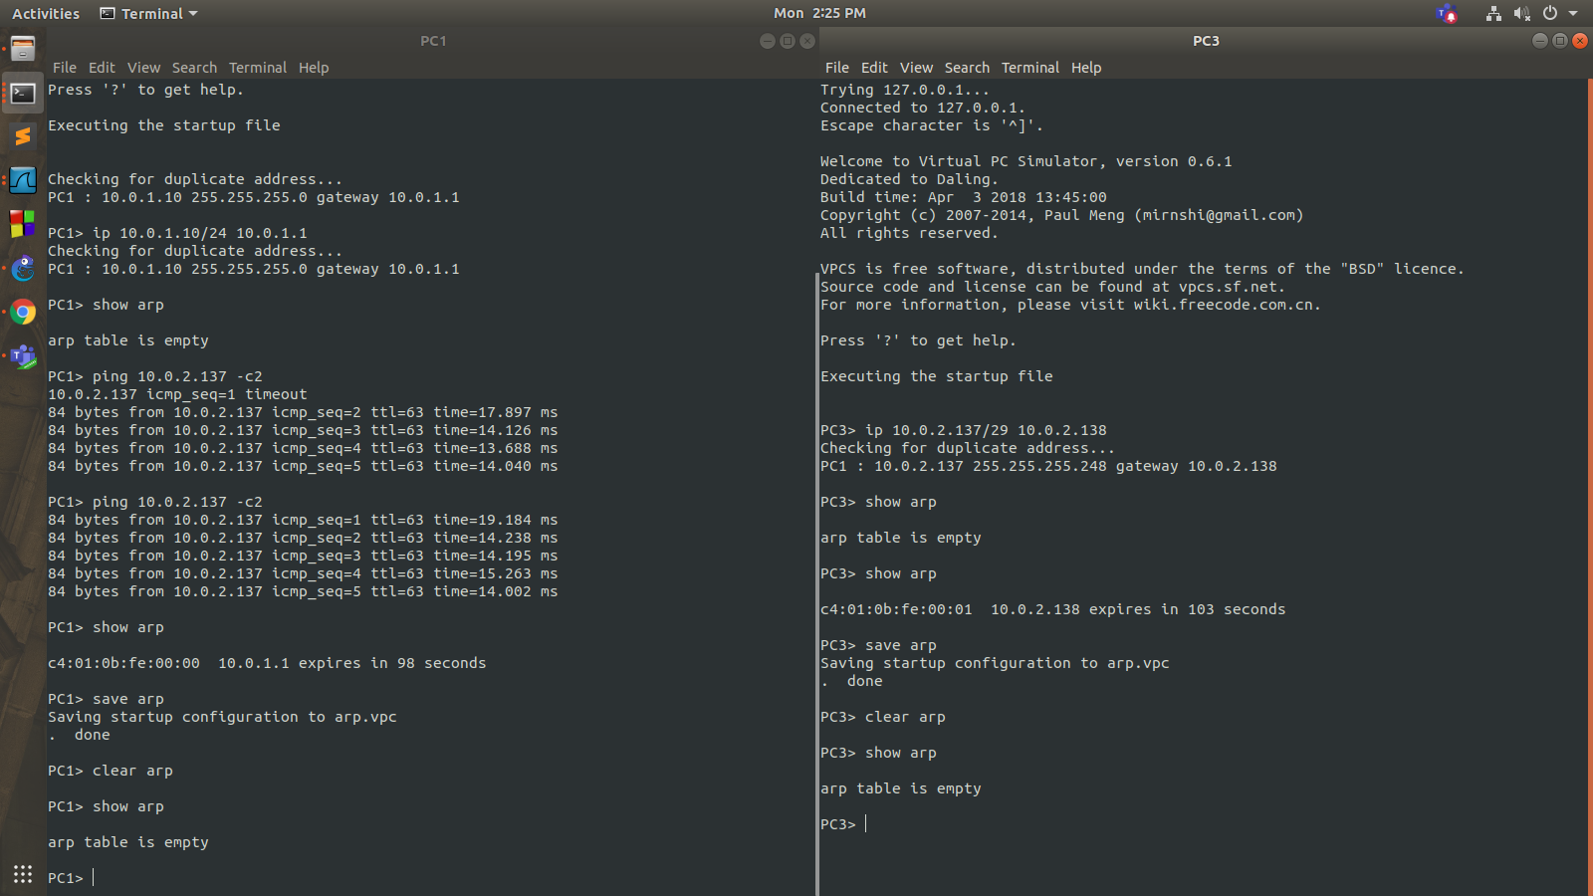

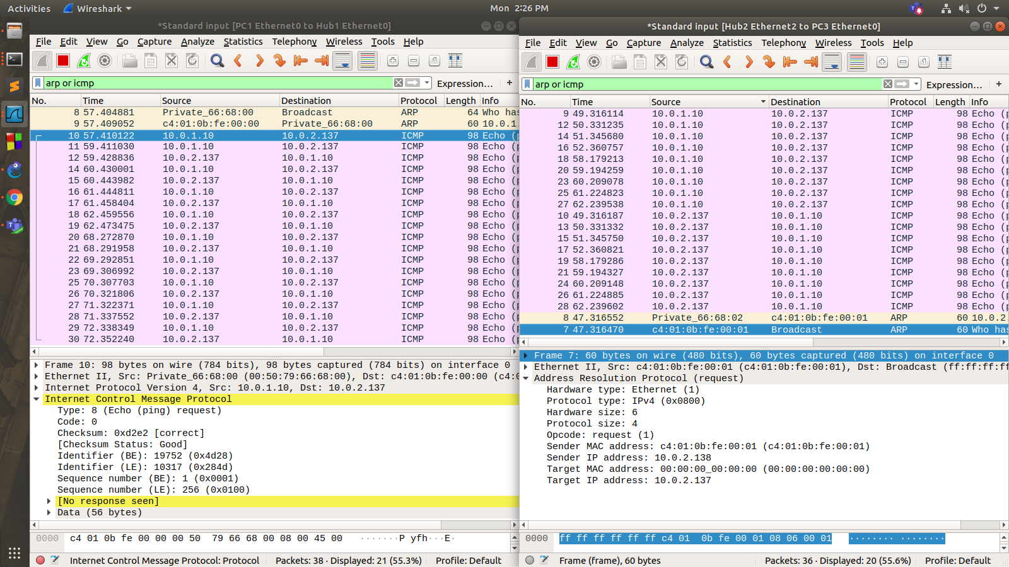

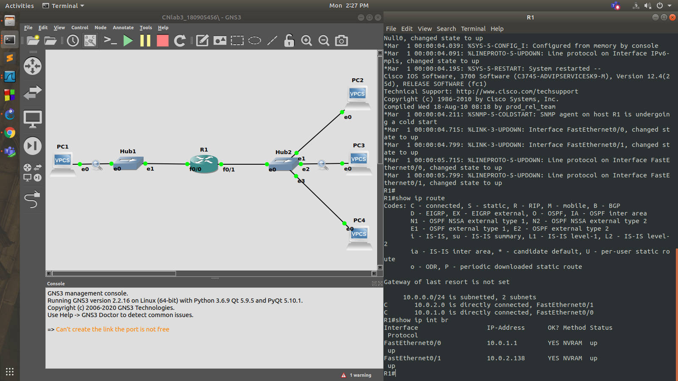

Ping from PC1 to PC2 and PC4

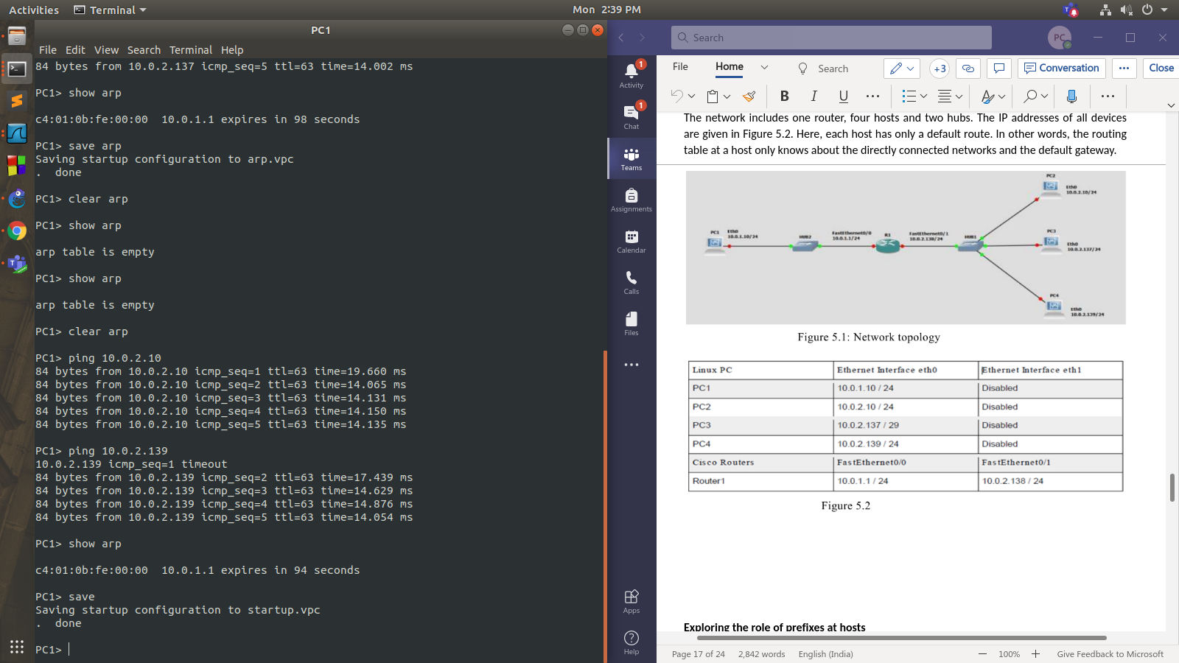

Ping from PC3 to PC4

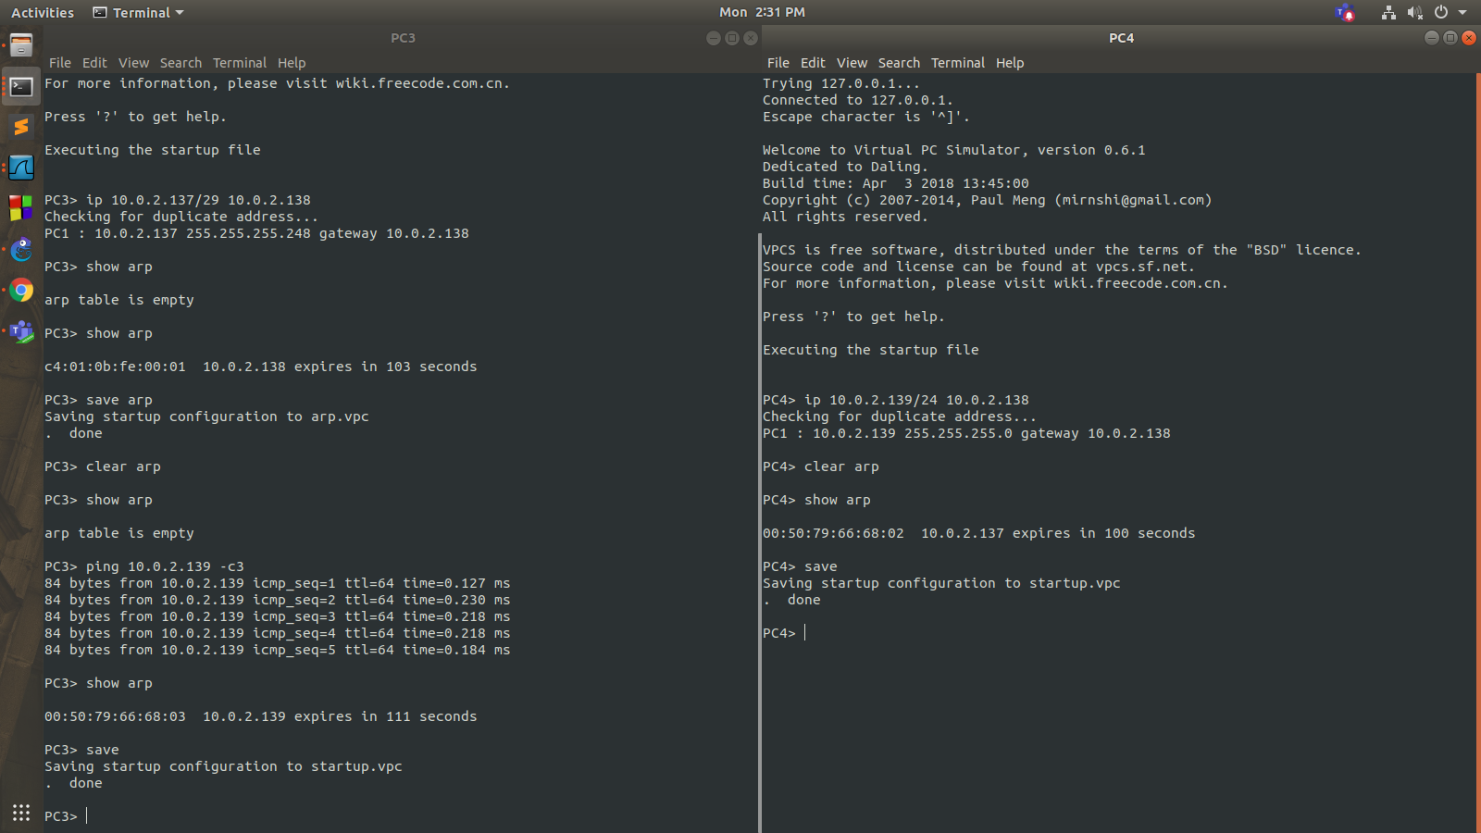

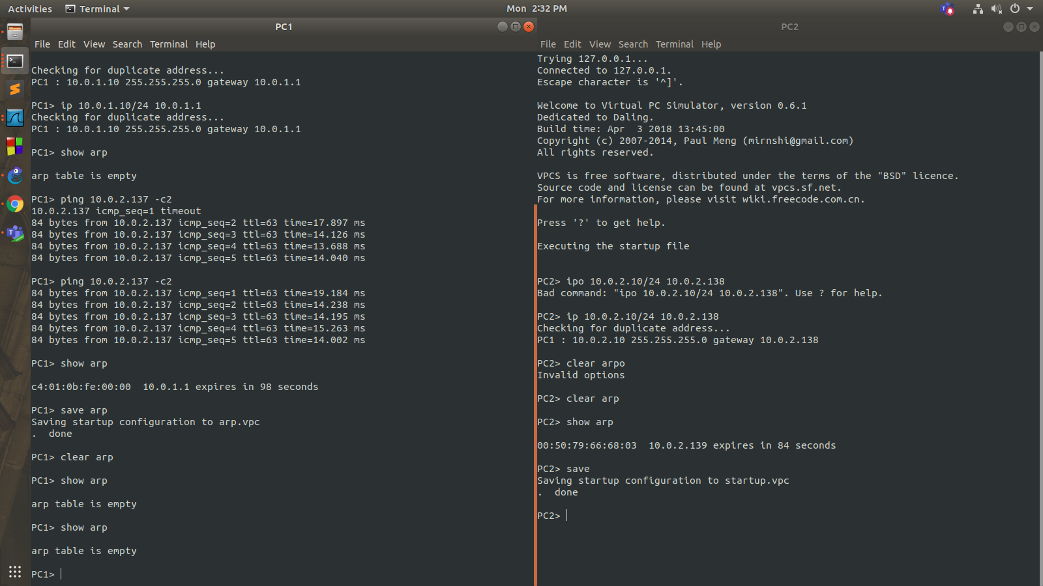

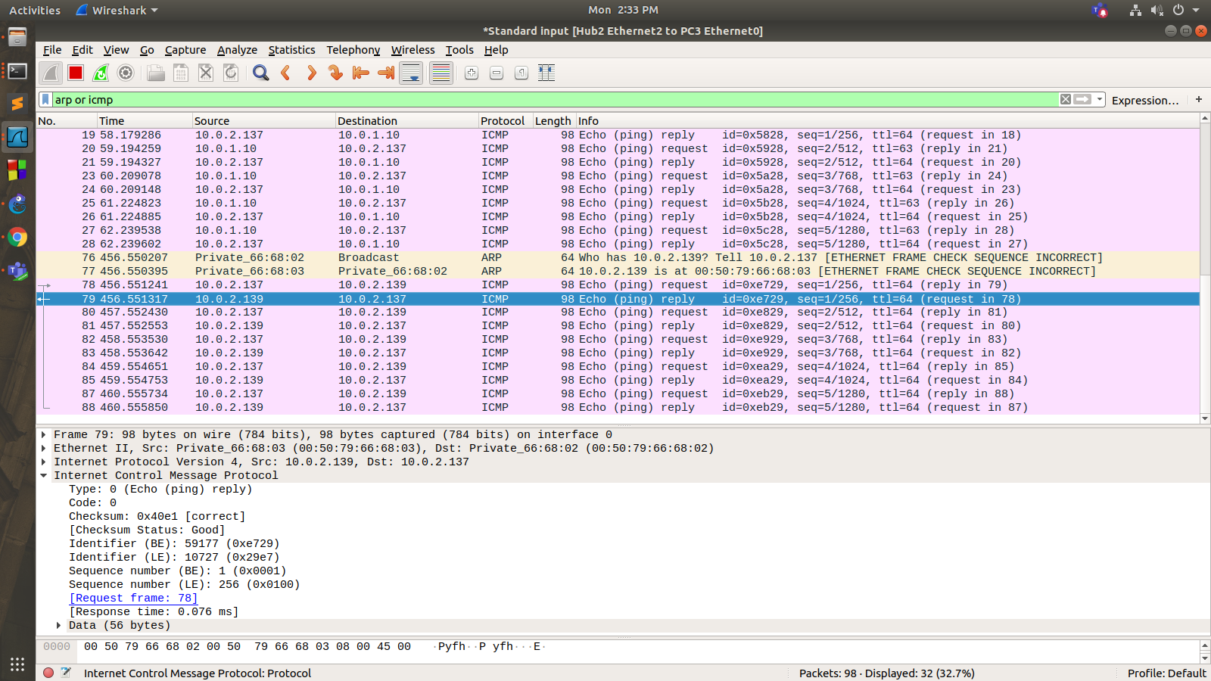

Ping from PC3 to PC2

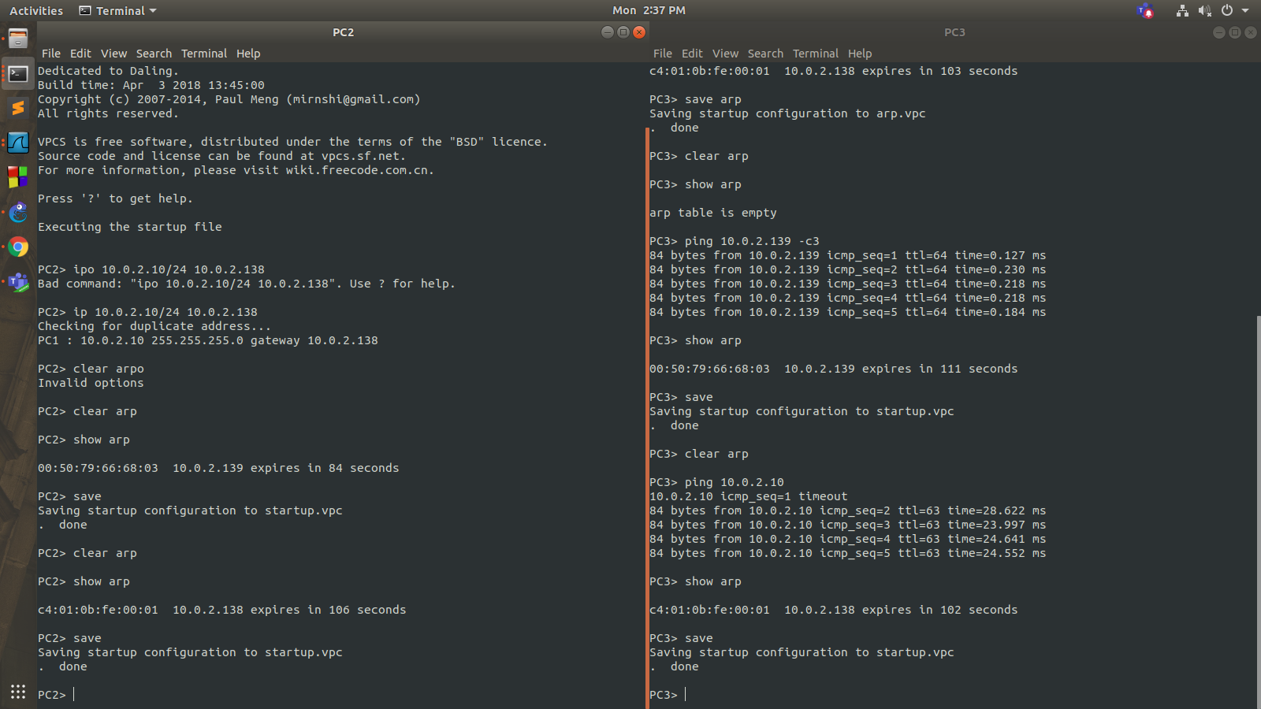

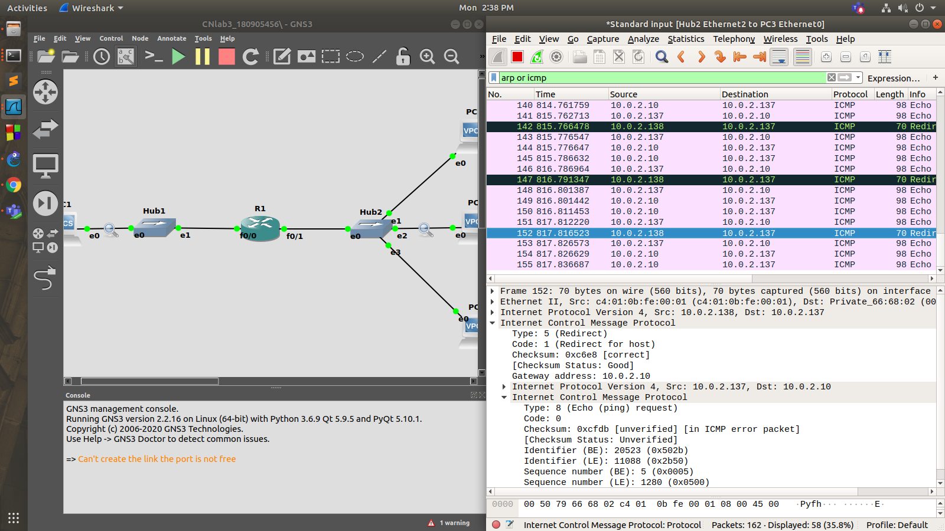

**Question 2**

Router configurations

**R1:**

R1#enable

R1#conf t

Enter configuration commands, one per line. End with CNTL/Z.

R1(config)#interface f0/0

R1(config-if)#ip add 14.24.74.193 255.255.255.240

R1(config-if)#no shutdown

R1(config-if)#

*Mar 1 00:01:37.895: %LINK-3-UPDOWN: Interface FastEthernet0/0, changed state to up

*Mar 1 00:01:38.895: %LINEPROTO-5-UPDOWN: Line protocol on Interface FastEthernet0/0, changed state to up

R1(config-if)#exit

R1(config)#interface f0/1

R1(config-if)#ip add 10.0.1.1 255.255.255.0

R1(config-if)#no shutdown

R1(config-if)#

*Mar 1 00:02:10.395: %LINK-3-UPDOWN: Interface FastEthernet0/1, changed state to up

*Mar 1 00:02:11.395: %LINEPROTO-5-UPDOWN: Line protocol on Interface FastEthernet0/1, changed state to up

R1(config-if)#exit

R1(config)#end

R1#

*Mar 1 00:02:18.031: %SYS-5-CONFIG_I: Configured from console by console

R1#write

Building configuration...

[OK]

R1#conf t

Enter configuration commands, one per line. End with CNTL/Z.

R1(config)#ip route 14.24.74.128 255.255.255.192 10.0.1.2

R1(config)#ip route 14.24.74.0 255.255.255.128 10.0.1.3

R1(config)#exit

R1#writ

*Mar 1 00:05:37.079: %SYS-5-CONFIG_I: Configured from console by console

R1#write

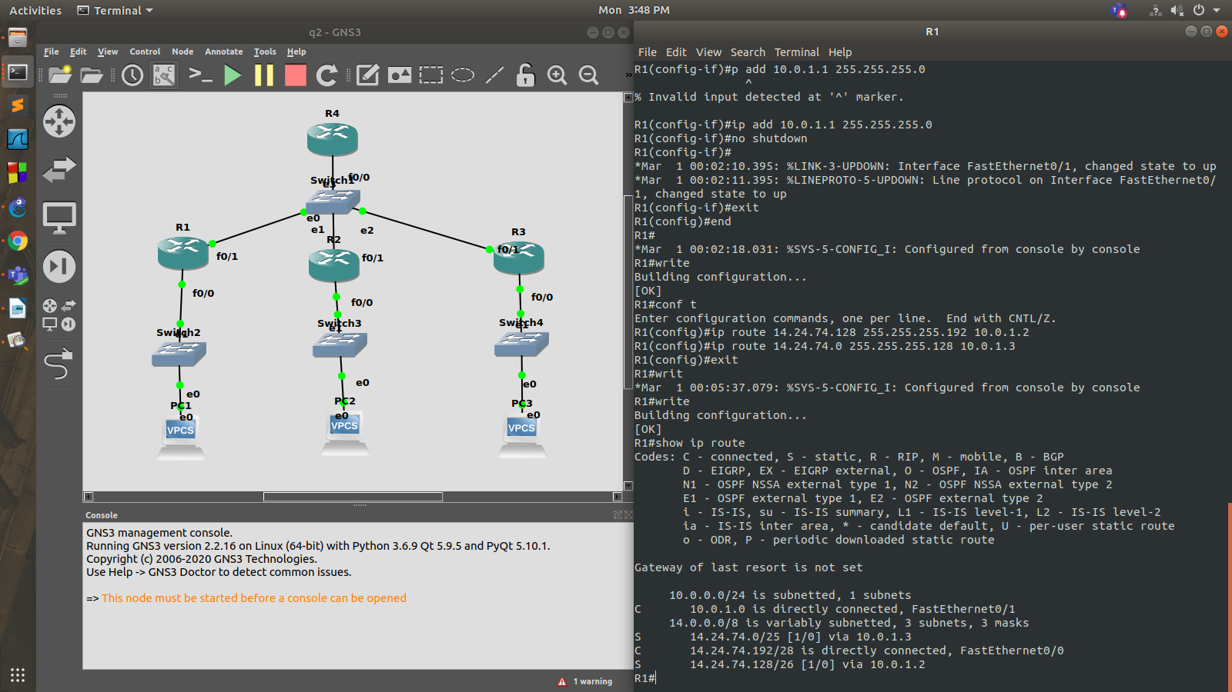

**R2:**

R2#enable

R2#conf t

Enter configuration commands, one per line. End with CNTL/Z.

R2(config)#interface f0/1

R2(config-if)#ip add 10.0.1.2 255.255.255.0

R2(config-if)#no shutdown

R2(config-if)#

*Mar 1 00:03:07.707: %LINK-3-UPDOWN: Interface FastEthernet0/1, changed state to up

*Mar 1 00:03:08.707: %LINEPROTO-5-UPDOWN: Line protocol on Interface FastEthernet0/1, changed state to up

R2(config-if)#exit

R2(config)#interface f0/0

R2(config-if)#ip add 14.24.74.129 255.255.255.192

R2(config-if)#no shutdown

R2(config-if)#

*Mar 1 00:03:39.551: %LINK-3-UPDOWN: Interface FastEthernet0/0, changed state to up

*Mar 1 00:03:40.551: %LINEPROTO-5-UPDOWN: Line protocol on Interface FastEthernet0/0, changed state to up

R2(config-if)#end

R2#

*Mar 1 00:03:43.811: %SYS-5-CONFIG_I: Configured from console by console

R2#write

Building configuration...

[OK]

R2#conf t

Enter configuration commands, one per line. End with CNTL/Z.

R2(config)#ip route 14.24.74.192 255.255.255.240 10.0.1.1

R2(config)#exit

R2#write

*Mar 1 00:06:25.779: %SYS-5-CONFIG_I: Configured from console by console

R2#write

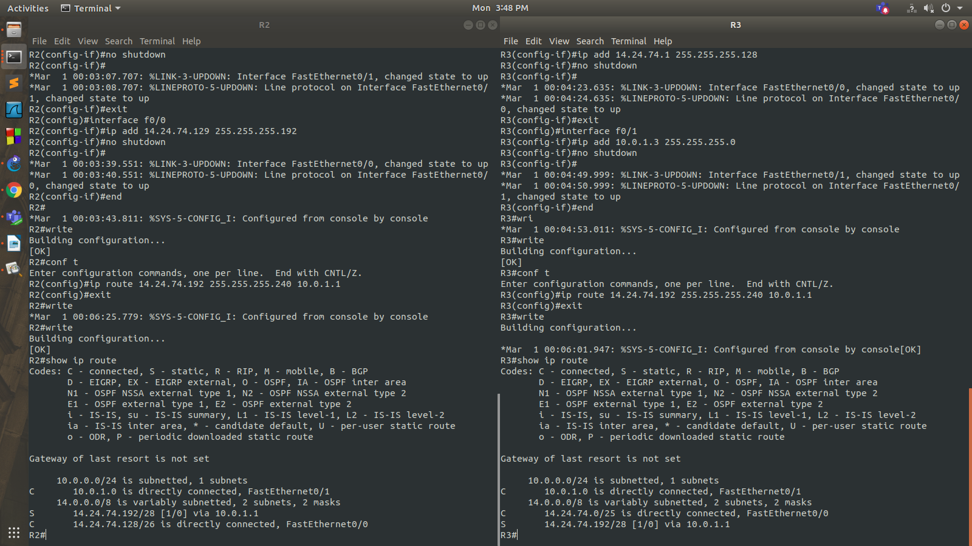

**R3:**

R3#enable

R3#conf t

Enter configuration commands, one per line. End with CNTL/Z.

R3(config)#interface f0/0

R3(config-if)#ip add 14.24.74.1 255.255.255.128

R3(config-if)#no shutdown

R3(config-if)#

*Mar 1 00:04:23.635: %LINK-3-UPDOWN: Interface FastEthernet0/0, changed state to up

*Mar 1 00:04:24.635: %LINEPROTO-5-UPDOWN: Line protocol on Interface FastEthernet0/0, changed state to up

R3(config-if)#exit

R3(config)#interface f0/1

R3(config-if)#ip add 10.0.1.3 255.255.255.0

R3(config-if)#no shutdown

R3(config-if)#

*Mar 1 00:04:49.999: %LINK-3-UPDOWN: Interface FastEthernet0/1, changed state to up

*Mar 1 00:04:50.999: %LINEPROTO-5-UPDOWN: Line protocol on Interface FastEthernet0/1, changed state to up

R3(config-if)#end

R3#wri

*Mar 1 00:04:53.011: %SYS-5-CONFIG_I: Configured from console by console

R3#write

Building configuration...

[OK]

R3#conf t

Enter configuration commands, one per line. End with CNTL/Z.

R3(config)#ip route 14.24.74.192 255.255.255.240 10.0.1.1

R3(config)#exit

R3#write

PC configurations and pinging from PC1 to PC2 and PC3

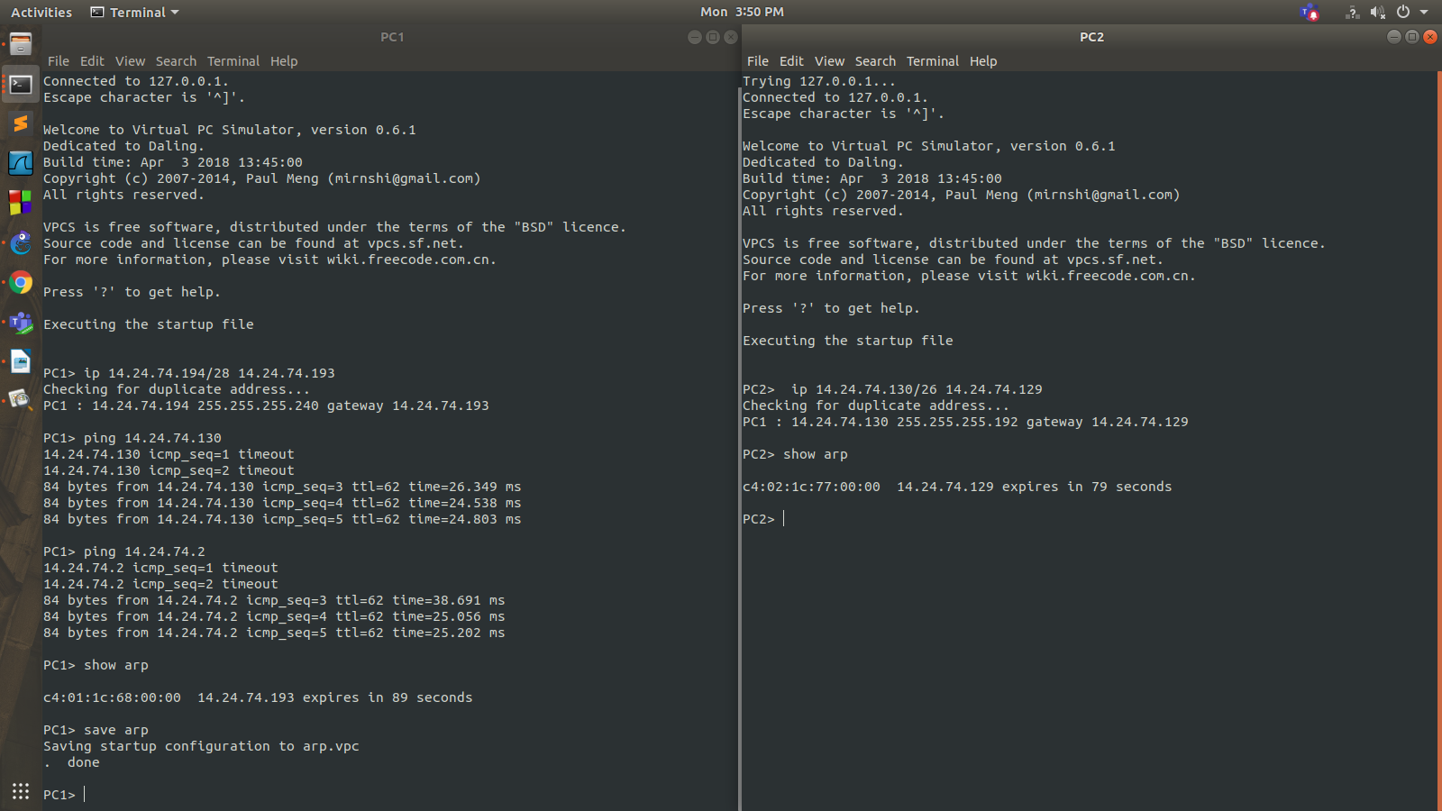

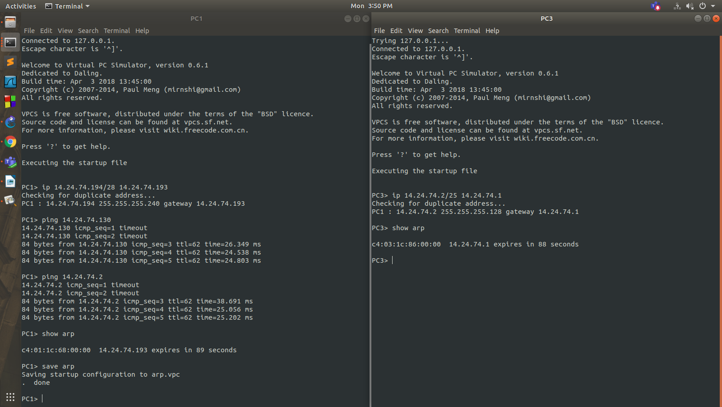

**Question 3**

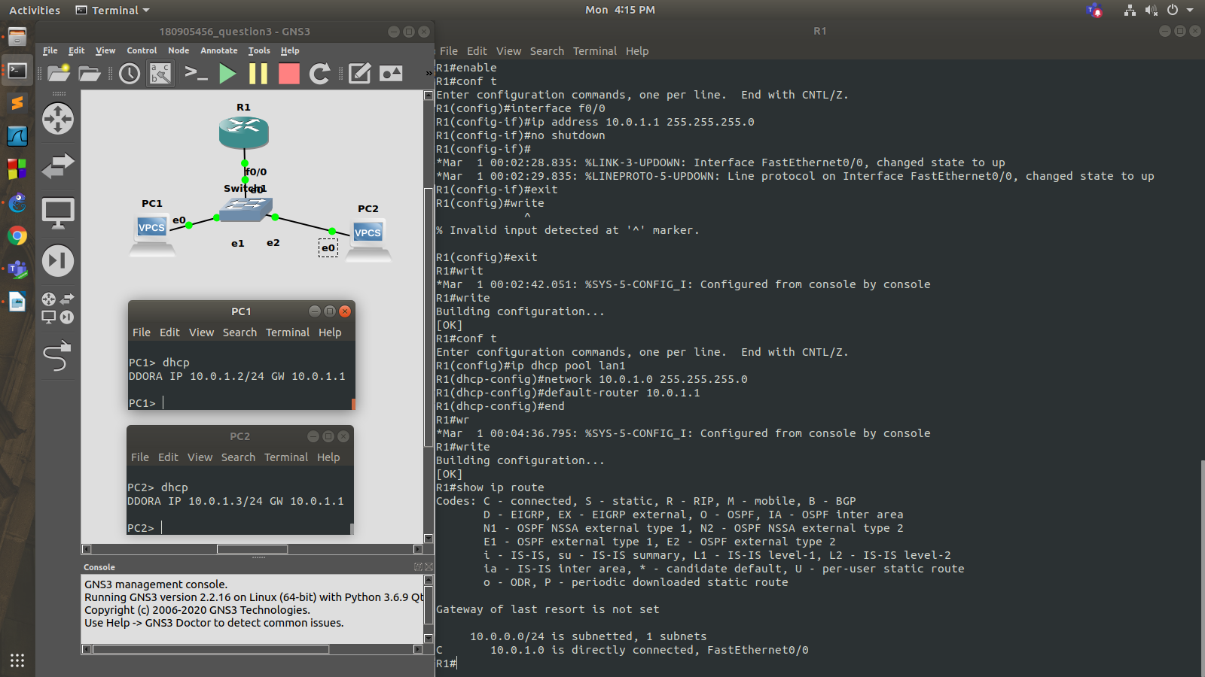

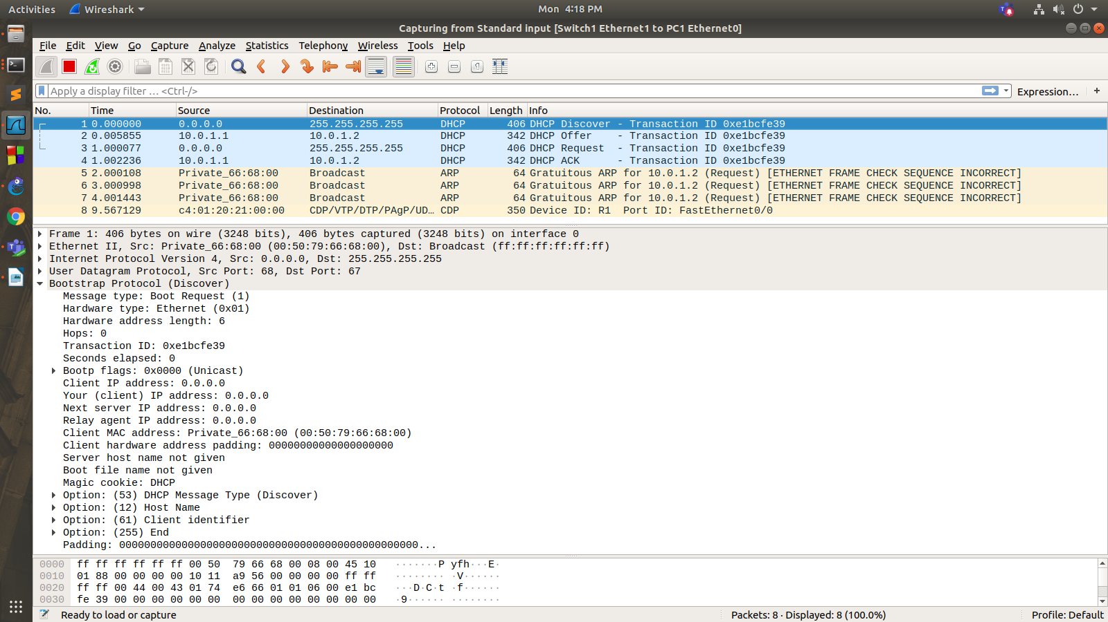

Router configuration

R1#enable

R1#conf t

Enter configuration commands, one per line. End with CNTL/Z.

R1(config)#interface f0/0

R1(config-if)#ip address 10.0.1.1 255.255.255.0

R1(config-if)#no shutdown

R1(config-if)#

*Mar 1 00:02:28.835: %LINK-3-UPDOWN: Interface FastEthernet0/0, changed state to up

*Mar 1 00:02:29.835: %LINEPROTO-5-UPDOWN: Line protocol on Interface FastEthernet0/0, changed state to up

R1(config-if)#exit

R1(config)#exit

*Mar 1 00:02:42.051: %SYS-5-CONFIG_I: Configured from console by console

R1#write

Building configuration...

[OK]

R1#conf t

Enter configuration commands, one per line. End with CNTL/Z.

R1(config)#ip dhcp pool lan1

R1(dhcp-config)#network 10.0.1.0 255.255.255.0

R1(dhcp-config)#default-router 10.0.1.1

R1(dhcp-config)#end

*Mar 1 00:04:36.795: %SYS-5-CONFIG_I: Configured from console by console

R1#write

**Question 4**

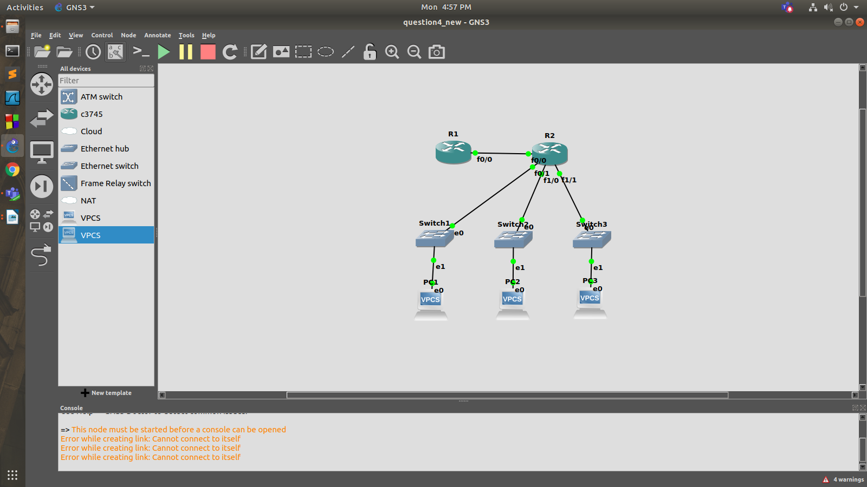

R1:

R1#enable

R1#conf t

Enter configuration commands, one per line. End with CNTL/Z.

R1(config)#ip dhcp pool lan1

R1(dhcp-config)#network 10.0.1.0 255.255.255.0

R1(dhcp-config)#default-router 10.0.1.1

R1(dhcp-config)#exit

R1(config)#ip dhcp pool lan2

R1(dhcp-config)#network 10.0.2.0 255.255.255.0

R1(dhcp-config)#default-router 10.0.2.1

R1(dhcp-config)#exit

R1(config)#ip dhcp pool lan3

R1(dhcp-config)#network 10.0.3.0 255.255.255.0

R1(dhcp-config)#default-router 10.0.3.1

R1(dhcp-config)#exit

R1(config)#ip route 10.0.1.0 255.255.255.0 30.0.0.2

R1(config)#ip route 10.0.2.0 255.255.255.0 30.0.0.2

R1(config)#ip route 10.0.3.0 255.255.255.0 30.0.0.2

R1(config)#exit

*Mar 1 00:03:37.071: %SYS-5-CONFIG_I: Configured from console by console

R1#write

Building configuration...

[OK]

R2:

R2#enable

R2#conf t

Enter configuration commands, one per line. End with CNTL/Z.

R2(config)#int f0/0

R2(config-if)#ip helper-address 30.0.0.1

R2(config-if)#no shutdown

R2(config-if)#

*Mar 1 00:03:02.495: %LINK-3-UPDOWN: Interface FastEthernet0/0, changed state to up

*Mar 1 00:03:03.495: %LINEPROTO-5-UPDOWN: Line protocol on Interface FastEthernet0/0, changed state to up

R2(config-if)#end

R2#wr

*Mar 1 00:03:07.323: %SYS-5-CONFIG_I: Configured from console by console

R2#write

Building configuration...

[OK]

R2#conf t

Enter configuration commands, one per line. End with CNTL/Z.

R2(config)#int f1/0

R2(config-if)#ip add 10.0.1.1 255.255.255.0

R2(config-if)#ip helper-address 30.0.0.1

R2(config-if)#no shutdown

R2(config-if)#

*Mar 1 00:05:05.671: %LINK-3-UPDOWN: Interface FastEthernet1/0, changed state to up

*Mar 1 00:05:06.671: %LINEPROTO-5-UPDOWN: Line protocol on Interface FastEthernet1/0, changed state to up

R2(config-if)#exit

R2(config)#int e2/0

R2(config-if)#ip add 10.0.2.1 255.255.255.0

R2(config-if)#ip helper-address 30.0.0.1

R2(config-if)#no shutdown

R2(config-if)#

*Mar 1 00:06:03.051: %LINK-3-UPDOWN: Interface Ethernet2/0, changed state to up

*Mar 1 00:06:04.051: %LINEPROTO-5-UPDOWN: Line protocol on Interface Ethernet2/0, changed state to up

R2(config-if)#exit

R2(config)#int e2/1

R2(config-if)#ip add 10.0.3.1 255.255.255.0

R2(config-if)#ip helper-address 30.0.0.1

R2(config-if)#no shutdown

R2(config-if)#

*Mar 1 00:06:45.915: %LINK-3-UPDOWN: Interface Ethernet2/1, changed state to up

*Mar 1 00:06:46.915: %LINEPROTO-5-UPDOWN: Line protocol on Interface Ethernet2/1, changed state to up

R2(config-if)#exit

R2(config)#int f0/0

R2(config-if)#ip add 30.0.0.2 255.255.255.0

R2(config-if)#no shutdown

R2(config-if)#end

R2#write

Building configuration...

[OK]

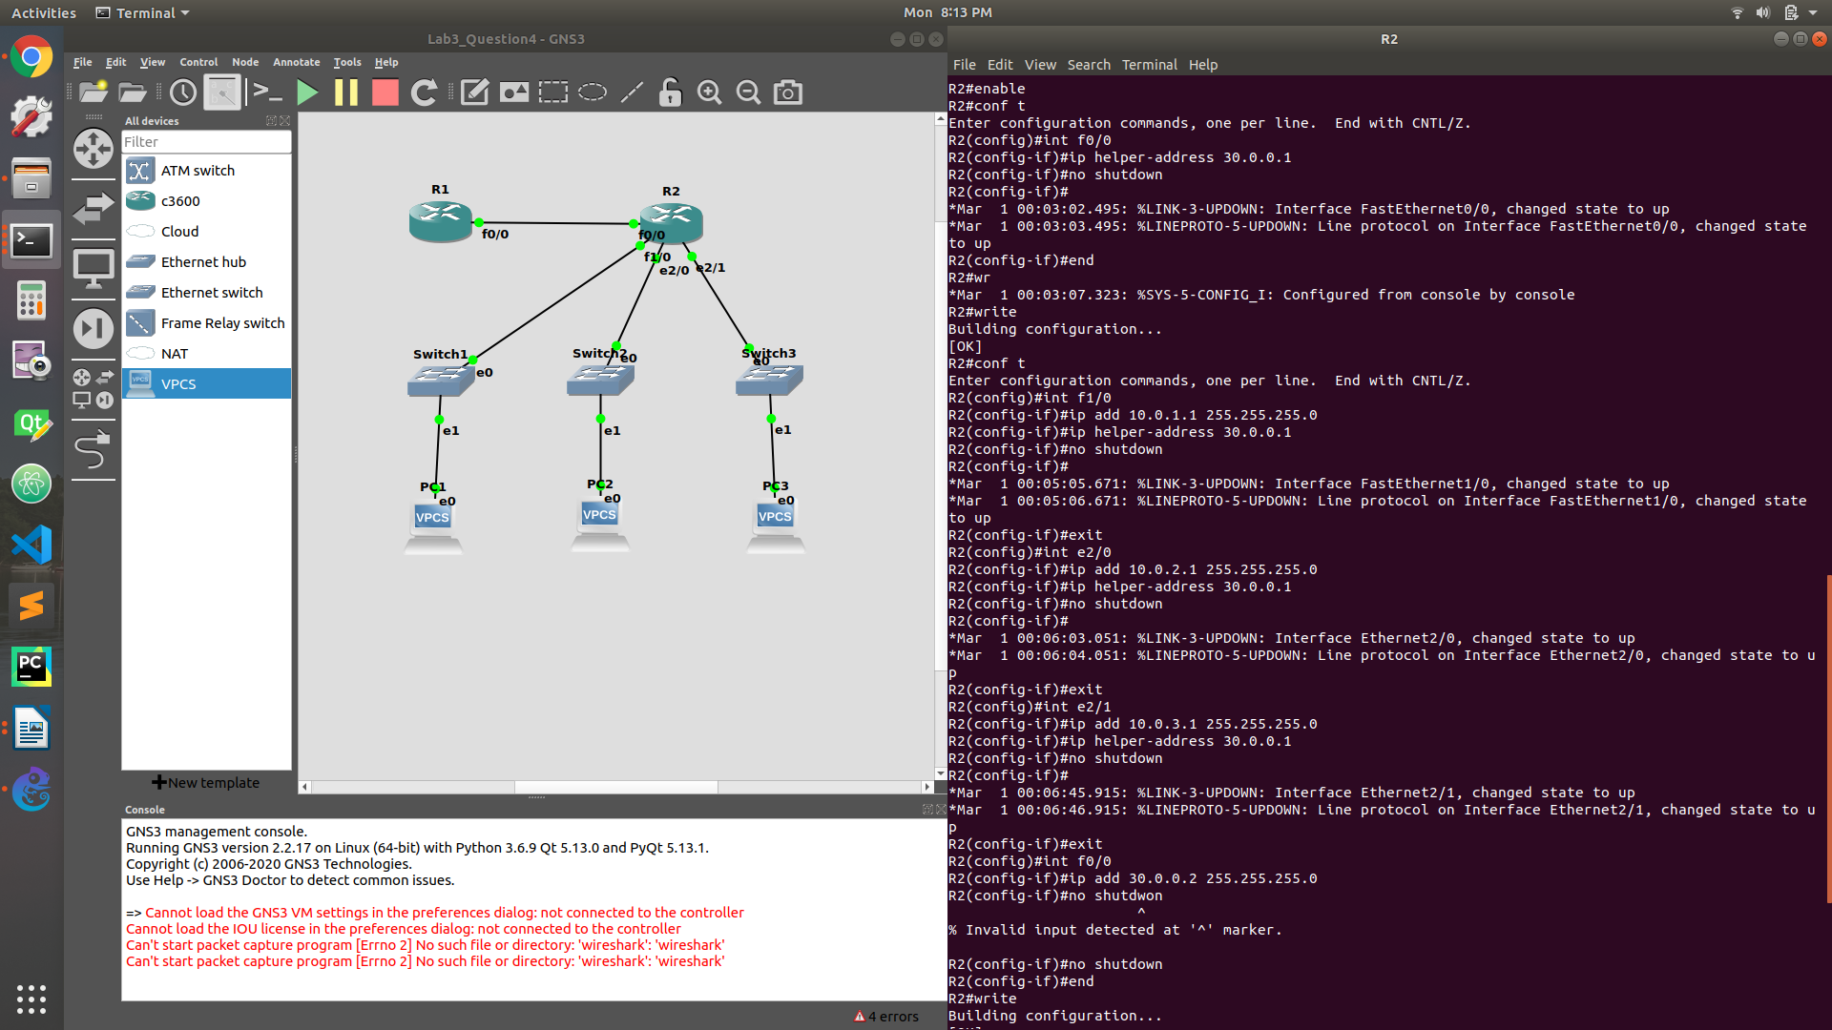

PC1> dhcp

DDORA IP 10.0.1.2/24 GW 10.0.1.1

PC3> dhcp

DDORA IP 10.0.3.2/24 GW 10.0.3.1

**Question 5**

R4#enable

R4#conf t

Enter configuration commands, one per line. End with CNTL/Z.

R4(config)#int f0/0

R4(config-if)#ip add 10.0.1.5 255.255.255.0

R4(config-if)#no shutdown

R4(config-if)#exit

*Dec 14 11:00:30.691: %LINK-3-UPDOWN: Interface FastEthernet0/0, changed state to up

R4(config-if)#exit

*Dec 14 11:00:30.691: %ENTITY_ALARM-6-INFO: CLEAR INFO Fa0/0 Physical Port Administrative State Down

*Dec 14 11:00:31.691: %LINEPROTO-5-UPDOWN: Line protocol on Interface FastEthernet0/0, changed state to up

R4(config-if)#exit

R4(config)#ip dhcp pool lan1

R4(dhcp-config)#network 14.24.74.192 255.255.255.240

R4(dhcp-config)#default-router 14.24.74.193

R4(dhcp-config)#exit

R4(config)#ip dhcp pool lan2

R4(dhcp-config)#network 14.24.74.128 255.255.255.192

R4(dhcp-config)#default-router 14.24.74.129

R4(dhcp-config)#exit

R4(config)#ip dhcp pool lan3

R4(dhcp-config)#network 14.24.74.0 255.255.255.0

R4(dhcp-config)#default-router 14.24.74.1

R4(dhcp-config)#exit

R4(config)#exit

R4#write

Building configuration...

[OK]

R4#

*Dec 14 11:03:44.023: %SYS-5-CONFIG_I: Configured from console by console

R4#conf t

Enter configuration commands, one per line. End with CNTL/Z.

R4(config)#ip route 14.24.74.192 255.255.255.240 10.0.1.1

R4(config)#ip route 14.24.74.128 255.255.255.192 10.0.1.2

R4(config)#ip route 14.24.74.0 255.255.255.128 10.0.1.3

R4(config)#exit

R4#write

Building configuration...

*Dec 14 11:06:29.895: %SYS-5-CONFIG_I: Configured from console by console[OK]

R4#

PC1> dhcp

DDORA IP 14.24.74.194/28 GW 14.24.74.192